FACULTY OF COMPUTER SCIENCE AND ENGINEERING

Ghulam Ishaq Khan Institute of Engineering Sciences and Technology, Topi

Lab Duration: 3 hrs. CS311L Operating System Lab Marks: 10

lab5

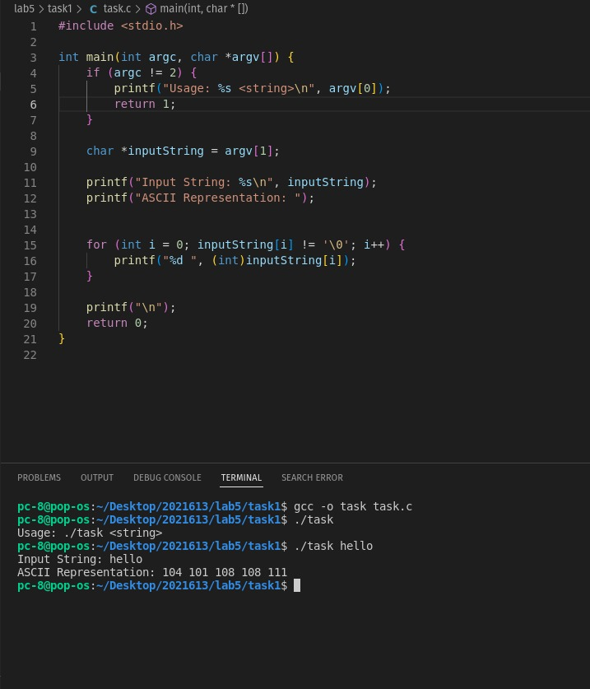task 1:

task 2:

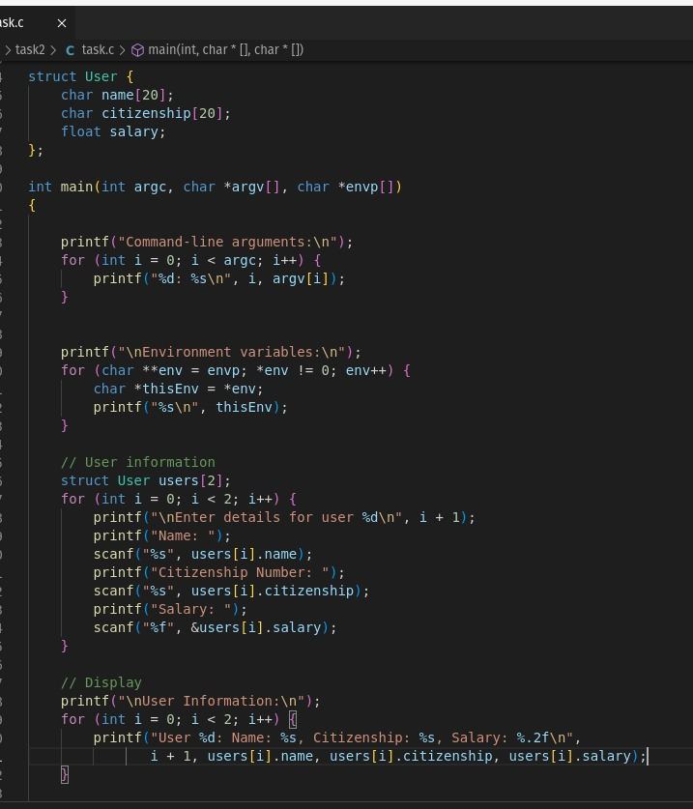

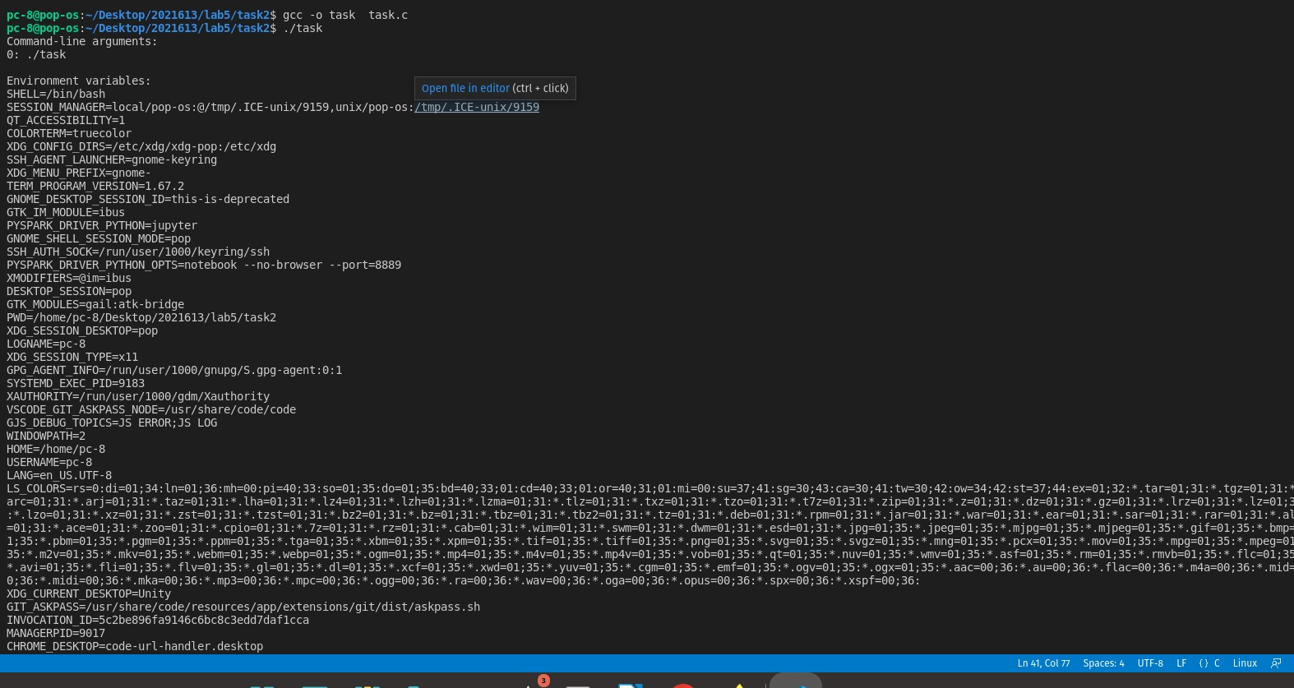.

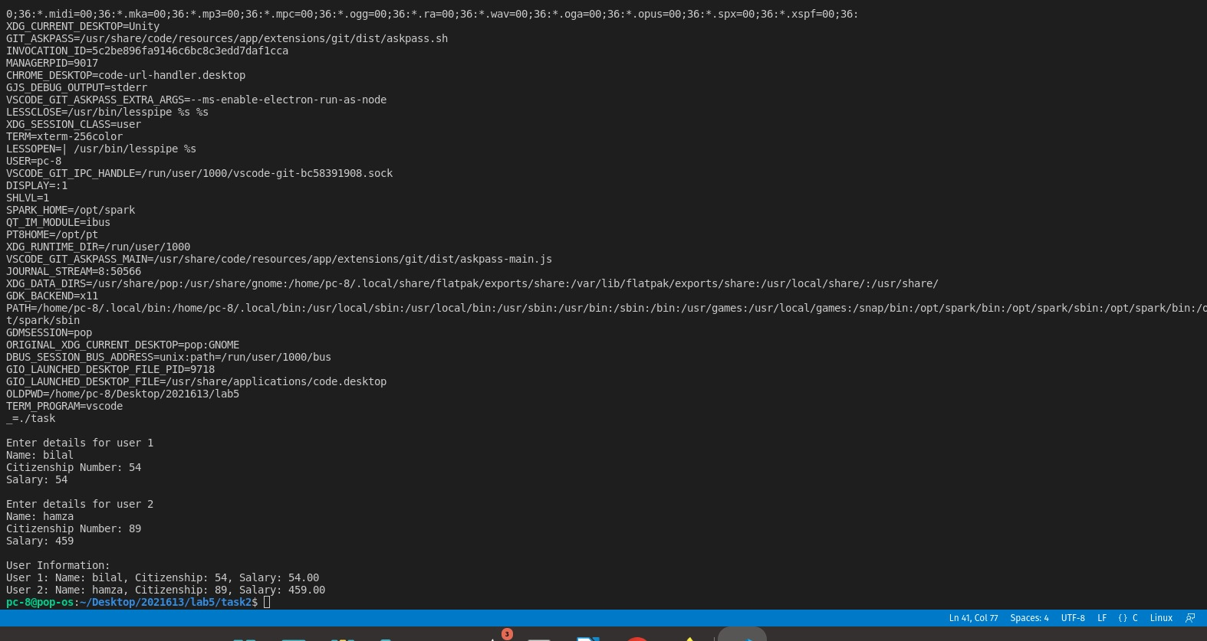.

task 3:



